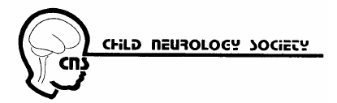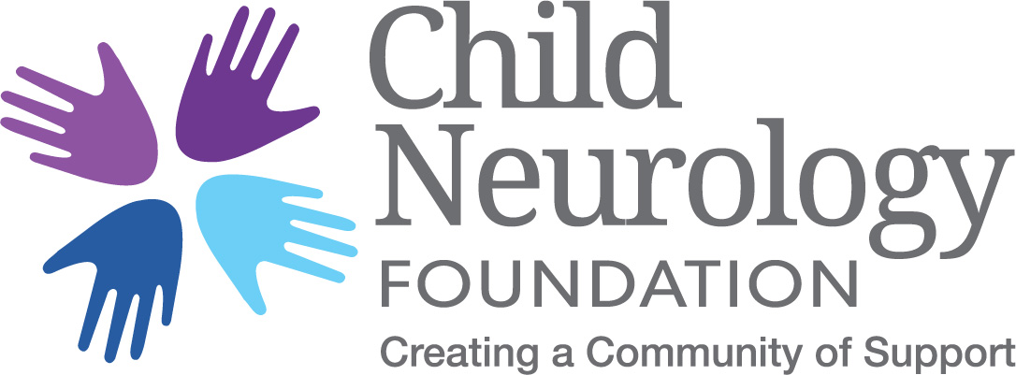

Child Neurology Society and Foundation Awards Committee

Dr. Kenneth Swaiman, one of the nation’s first pediatric neurologists, founded the Child Neurology Society in 1972 and established the Child Neurology Foundation in 2001. While the Society is the professional organization for the nation’s pediatric neurologists, the Foundation is committed to serving as a connective center of education and support for children and their families living with neurologic conditions. This year for the first time the Awards granted in the past by the Child Neurology Foundation will be added to those given by the Child Neurology Society. Child neurologists of the CNS and CNF have developed a specialized committee to fulfill this function with the following Awards and Grants offered to members of the CNS:

The Philip R. Dodge Young Investigator Award is an award for basic science or clinical research by promising young investigators who are members of the Child Neurology Society. Applications will be judged on the basis of originality, scientific merit, succinctness and relevance. The recipient of the Dodge award will receive a grant-in-aid of $20,000 and will be invited to present their work at the Annual Meeting of the Child Neurology Society.
- Eligibility Criteria
- 1. The applicant completed a pediatric neurology residency on or after June 30, 2012 or a neurodevelopmental disability residency on or after June 30, 2013, and graduated medical school on or after May 2007, or after May 2006 if the applicant completed a 3-year pediatric residency.
- 2. The scientific work is mainly the result of the applicant's efforts.
- 3. The applicant is a Junior or Active member of the Child Neurology Society.
- 4. Candidates are NOT disqualified if they have received NIH funding.
- 5. Candidates should consider applying before their final year of eligibility.

The Child Neurology Shields Research Grant supports translational or clinical research by a child neurologist or developmental pediatrician early in his/her academic career. The selected investigator will receive a $100,000 grant of $50,000 per year for two years. The Shields Grant is supported by the Winokur Family Foundation and the Pediatric Epilepsy Research Foundation (PERF).
- Eligibility Criteria
- 1. The applicant must be a junior faculty member who has developed clinical research skills and has a plan for further development of that research or has basic science research skills related to child neurology and who has a plan to translate the new knowledge into clinical care for children with neurologic diseases.
- 2. The Shields Grant must have a clinical research /patient care component.
- 3. The applicant is a legal resident of the United States or Canada
- 4. The applicant is a Junior or Active member of the Child Neurology Society.
- 5. Candidates are NOT disqualified if they have received NIH funding.
- 6. A pre-application is no longer required.

Pediatric Epilepsy Research Foundation (PERF) Scientific Research Grant supports clinical or basic science research by a child neurologist or developmental pediatrician early in his/her academic career. The selected investigator will receive a $100,000 grant of $50,000 per year for two years. The PERF Grant is supported fully by PERF.
- Eligibility Criteria
- 1. The applicant completed training in child neurology or neurodevelopment disabilities in an ACGME-approved program no more than seven years prior to application.
- 2. The applicant is a legal resident of the United States or Canada
- 3. The applicant is a Junior or Active member of the Child Neurology Society.
- 4. Applicants with current or approved pending NIH funding will be excluded. No NIH grant is allowed, other than an institutional (i.e. K12, T32) or training grant (i.e. NRSA).

Applications for these Awards are due April 15. Applicants will be informed of the committee’s decision by July 1.

